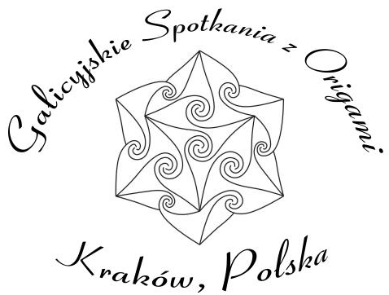
7th Outdoor Origami Meeting

Poręba near Cracow, Poland
2008.05.02-04

Registration card
Name:
Address:

e-mail:
phone:
Arrival date:
Departure date:
Reservation for nights and meals (tick please):
Thursday 01.05 □ bed (01/02)
Friday 02.05 □ breakfast □ lunch □ dinner □ bed (02/03)
Saturday 03.05: □ breakfast □ lunch □ dinner □ bed (03/04)
Sunday 04.05 □ breakfast □ lunch □ dinner □ bed (04/05)
I would like to share room with:
I prefer □ hotel / □ bungalow
I would like to learn:

I would like to teach □ yes / □ no (if yes fill the workshop registration form):
I learned abort convention from:

I am a member of:
□ PCO (Polish Origami Center)
□ PTO (Polish Origami Association – Paper Phantasies)
□ SNM (Mathematics’ Teachers Association)
□ OiM (Origami & Mathematics workgroup of SNM
□ other origami association
Remarks:

As we should pay for rooms, please send registration card till March 15 to Grzegorz (Greg) Bubniak grzegorz.bubniak@gmail.com with copy to burczyk@mail.zetosa.com.pl
You can contact us:
Elżbieta Udziela: +48/12/413 55 68
Krystyna Burczyk (mobile): +48/602/ 601 719,
Wojciech Burczyk (mobile): +48/695/270 268
burczyk@mail.zetosa.com.pl
Cost: conference fee: 35zł (30 zł for a member of any origami association worldwide), bed: 25zł/person/night, breakfast 8 zł, lunch 15 zł, dinner 8 zł.
Unless you mark otherwise we put your name and e-mail address on the participant list handed to all participants

