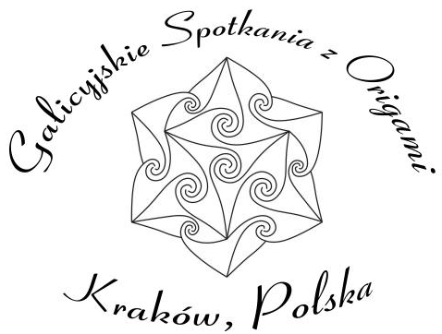
7th Outdoor Origami Meeting

Poręba near Cracow, Poland
2008.05.02-04

Workshop registration form
We encourage you to give workshop on our convention and show your favorite models or share your experience. You can teach a model (designed by you or somebody else) or give a lecture about origami techniques, theory of origami, your experience with origami in education. To make life easier give us some details about your workshop.
Name:

Title of workshop

Models you will teach or other description of your workshop
(model name, creator name, difficulty level, source of diagram – link to web page or author and title and page number of a book/magazine)

Time for the workshop
□ 45 minutes - half block □ 1hour and 45 minutes (105 minutes) – full block

Preferred time: (put date and time of arrival and departure, preference for morning / afternoon, etc.):

Other information abort workshop

Prepare a model you will teach for model menu.
You should prepare a paper for the participants of a workshop. We will cover a (reasonable) cost of materials. If you have a problem with transportation or luggage limit, contact us to make another arrangement.
Send this form till March 15th together with registration form by e-mail to:
Wojciech Burczyk burczyk@mail.zetosa.com.pl
You can reach us by phone
Elżbieta Udziela: +48/12/413 55 68
Wojciech Burczyk (mobile): +48/695/270 268
burczyk@mail.zetosa.com.pl

